Spring Cleaning Time Kingswood
  - LET’S MAKE IT BEAUTIFUL!
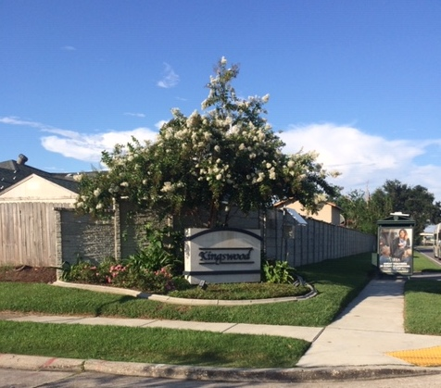
Motor Vehicles  Automobiles  It is prohibited to make major repairs to or dismantle a vehicle on your property. Vehicles shall not block sidewalks or driveways. NO Parking cars on grass it can create a mud hole which is unsightly! NO BLOCKING SIDEWALKS.  NO SPEEDING MPH: 25 | Animals  Leash law  ALL PETS SHALL BE ON A LEACH. OWNERS ARE RESPONSIBLE FOR CLEANING UP AND PROPERLY DISPOSAL OF ANIMAL WASTE. (City Ordinance Sec. 18-13) | grass, weeds, & trees  Landscaping  Yards shall not have weeds or grass taller than 10 inches. Grass should be moved along sidewalks and curbs. Do not blow grass onto city streets. It will clog catch basins! Dead trees are to be removed from your property.
 | 504.352.8155
CLEAN YOUR SURROUNDING!  Please do not throw water bottles/ trash on park grounds or throughout the subdivision. It can create a toxic environment. There are several trash bins to use to keep the environment clean, safe, and virus free.  www.kidnoe.org | 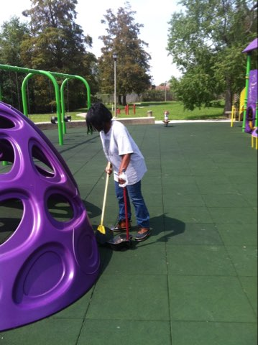
Homeownership  sales  Properties within Kingswood have been selling fast and we would like to welcome new homeowners to our community and the goal to make it a safe, clean, and secure environment for you and your family to enjoy for many generations to come!  www.kidnoe.org | Do you know there is a noise ordinance? Yes, Lets create a peaceful community!

Kingswood Community Who to Call list

list below are helpful telephone numbers of government agencies and business who may be able to help individuals find solutions to community issues
NOLA-311……………………… 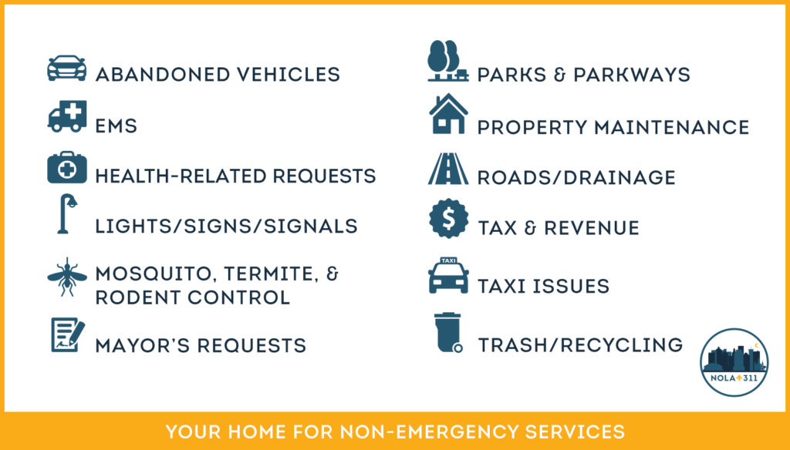
Always contact dial 911 in case of Police, Fire, or Medical Emergency
Police non-emergent….504.821.2222

ionon

lou
Use styles to easily format your Word documents in no time. For example, this text uses the Normal Style.
Some of the sample text in this document indicates the name of the style applied. To get started right away, just tap any placeholder text (such as this) and start typing. View and edit this document in Word on your computer, tablet, or phone.

www.kidnoe.org

“Find even more easy-to-use tools on the Insert tab, such as to add a hyperlink or insert a comment.”

